## INTRODUCTION.

# Overview.

# A brief description about your project.

# LOK SABHA CANDIDATES IN 2019

**This project is on a quantitative analysis of candidates in the 2019 lok sabha elections**

**The lok sabha is composed of representatives of people chosen by direct elections on the**

**Basis of Universal adult suffrage.The constitutions of india allows for a maximum of 550**

**Members in the house,with 530 members representing the states and 20 representing**

**The union territories.**

# 

# Purpose.

# The use of this project.What can be achived using this.

**The purpose of the project is to analyze quantitatively the lok sabha**

**Elections of 2019.**

**The Bharatiya Janata Party received 37.36% of the vote, the highest vote**

**Share by a political party since the 1989 general elections, and won 303**

**Seats, further increasing its substantial majority. In addition, the BJP-led**

**National Democratic Alliance (NDA) won 353 seats.**

# Problem Definition & Design Thinking.

# Empathy map.

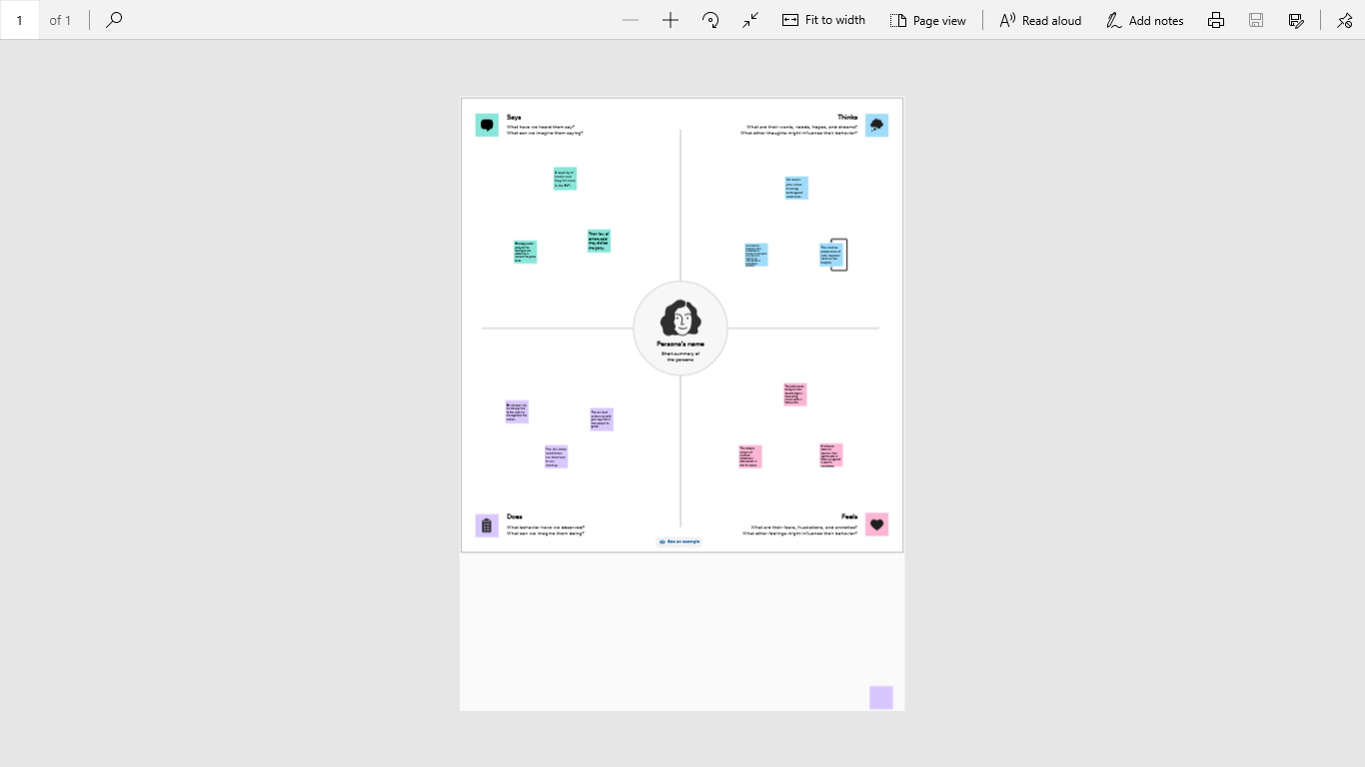

# Ideation & Brainstroming map.

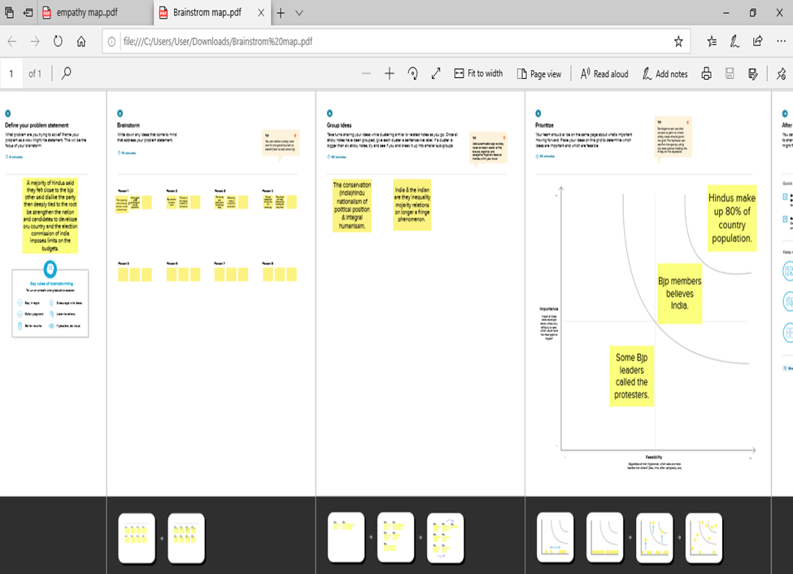

# Result

# Visualization.

# 

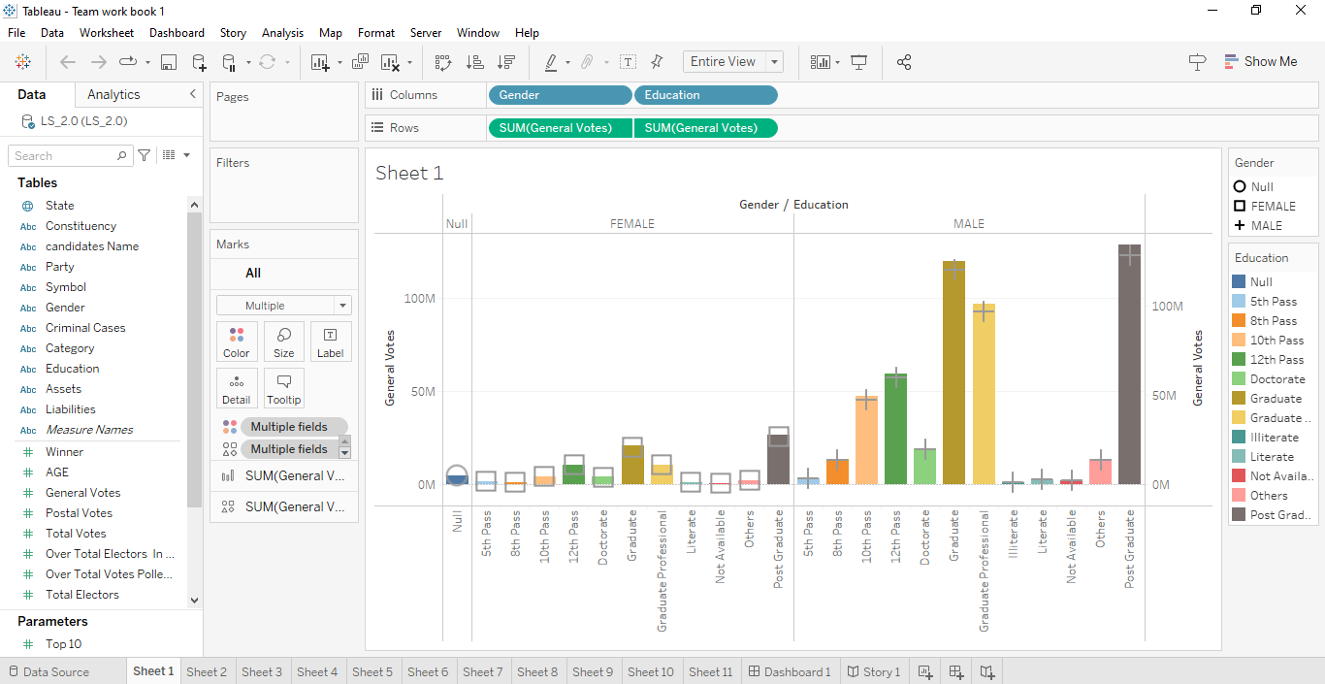

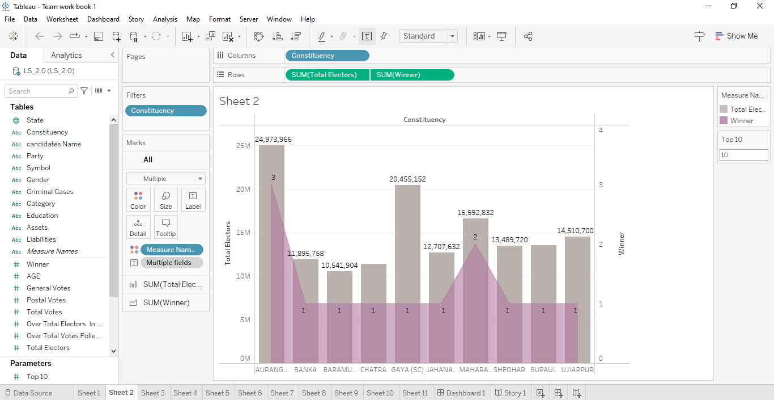

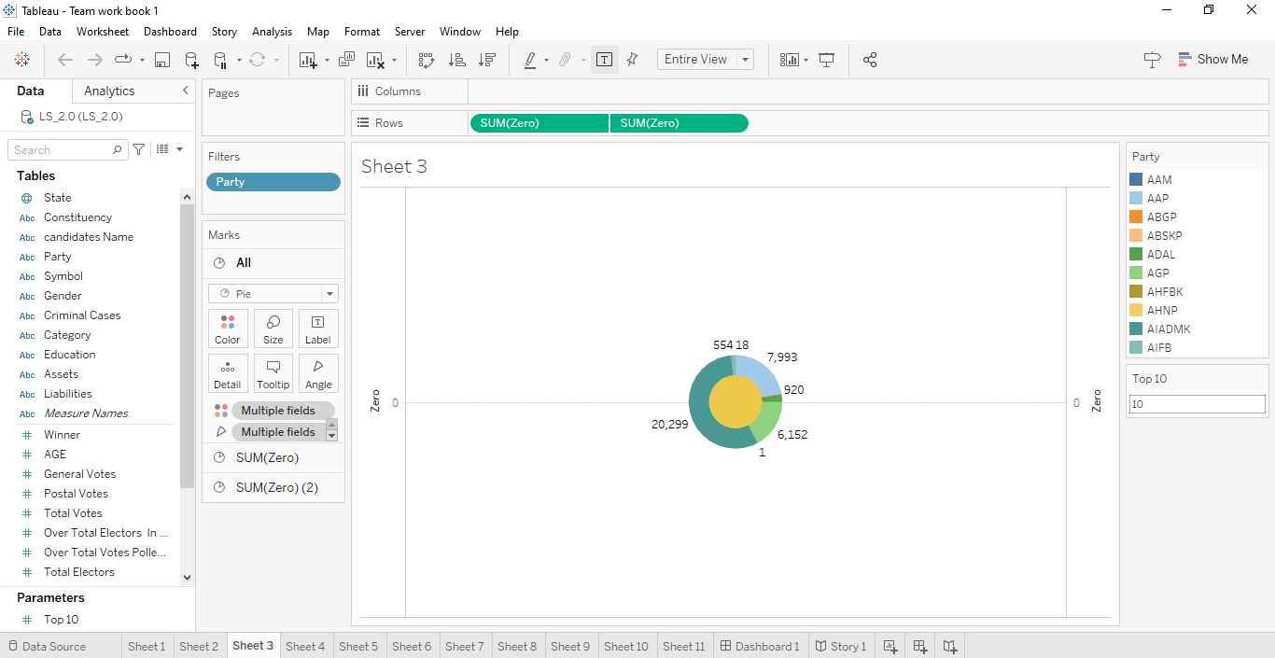

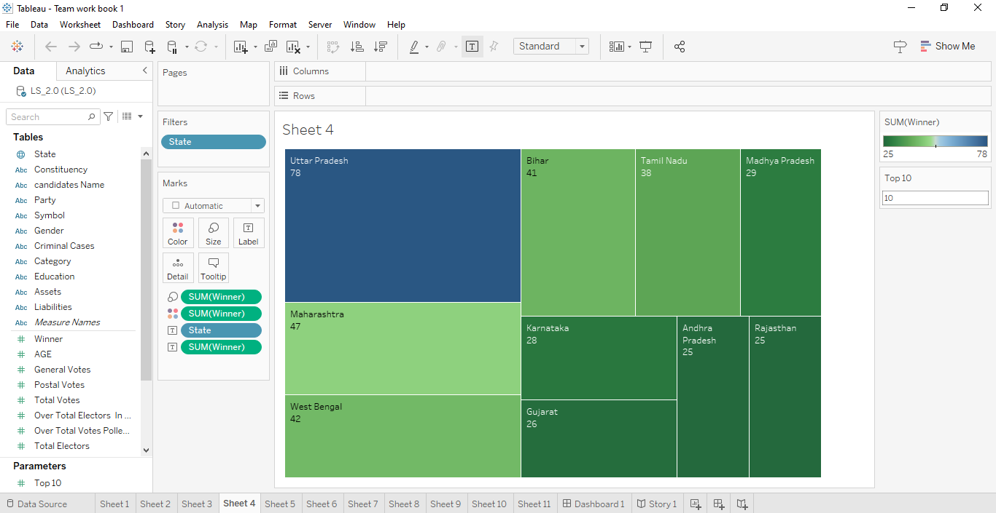

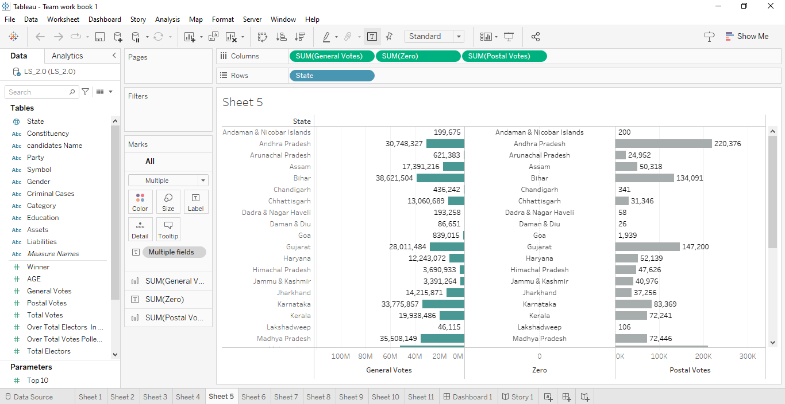

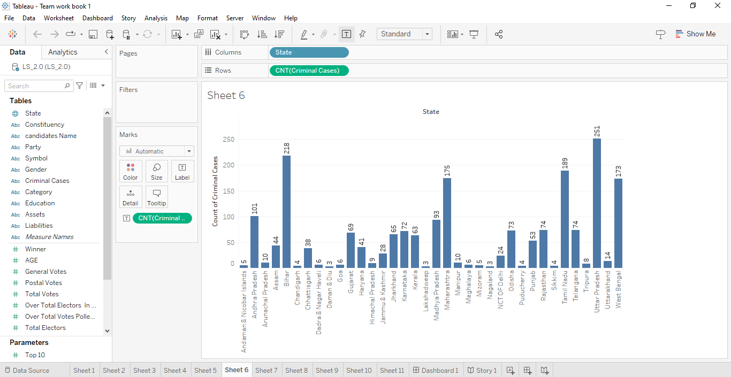

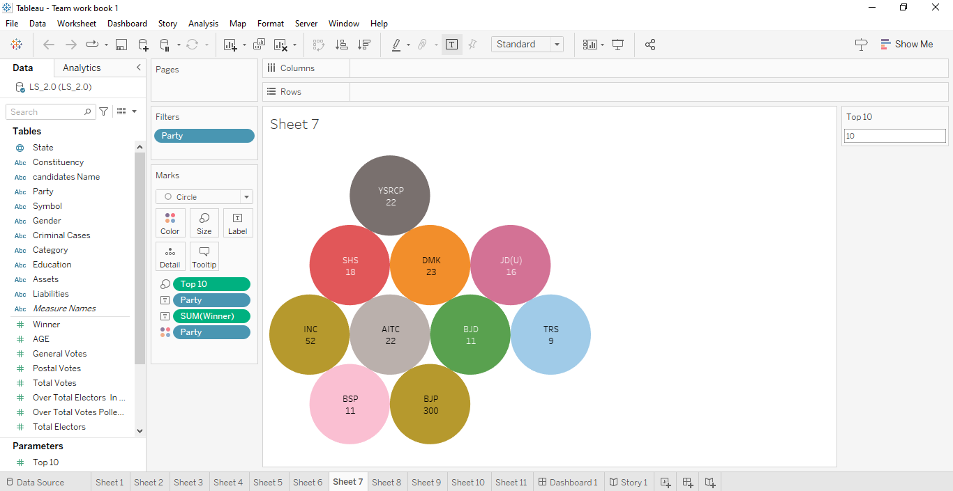

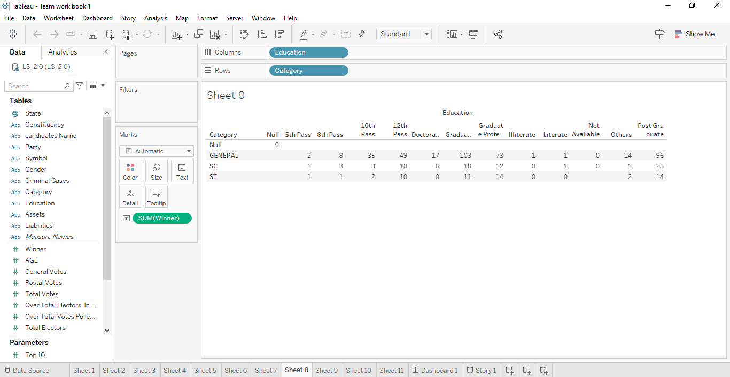

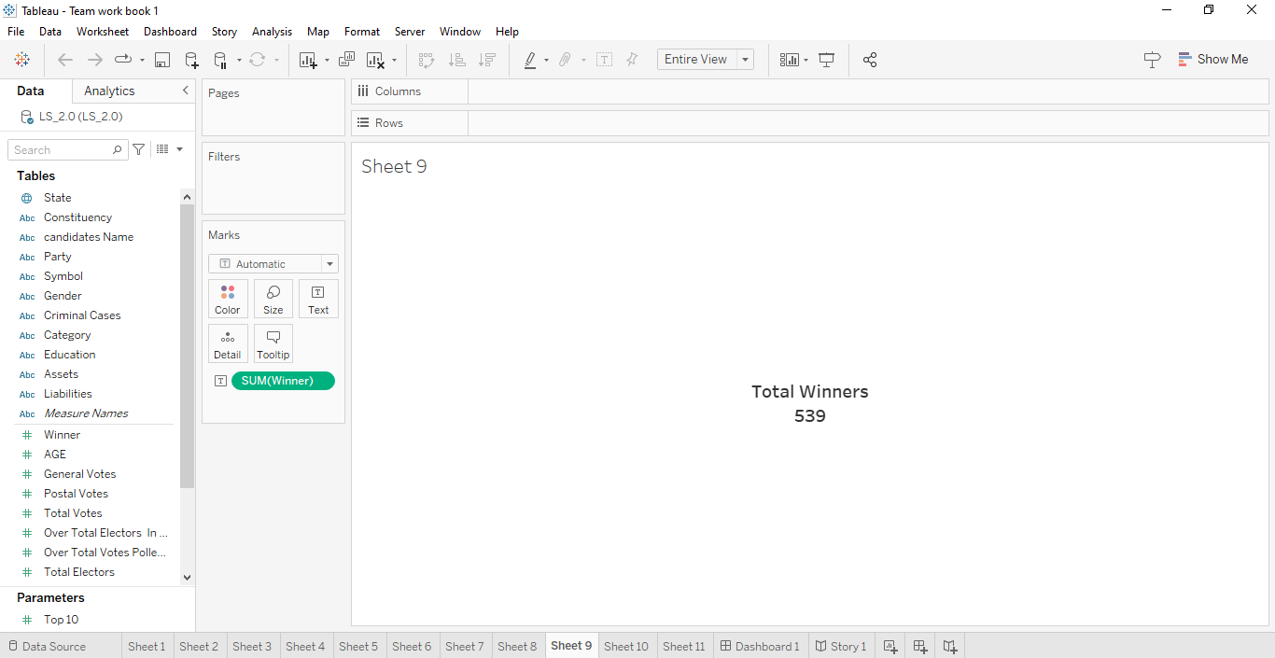

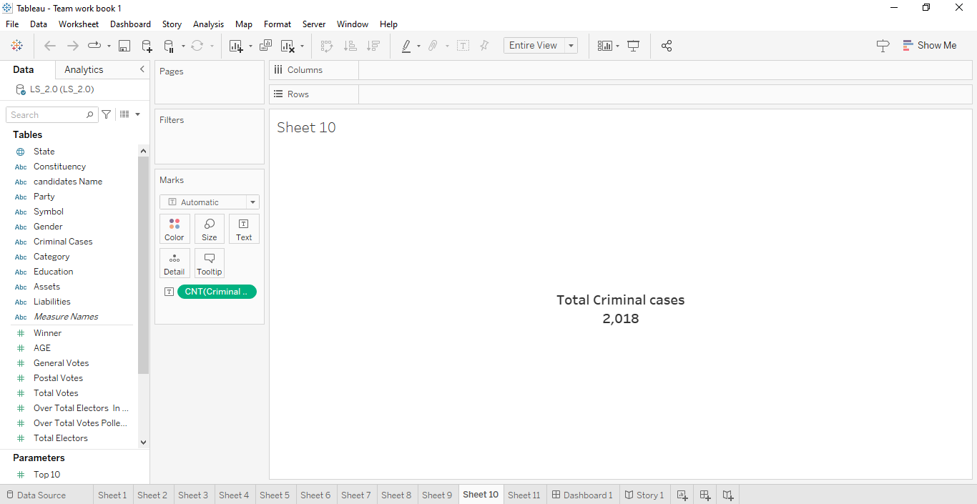

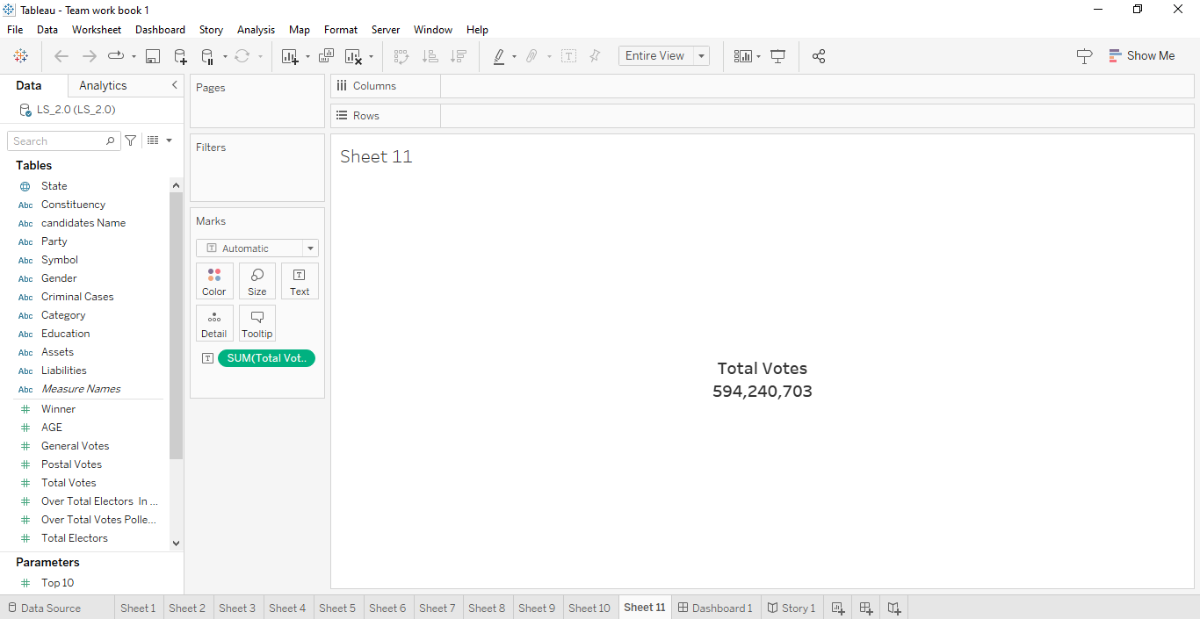

# Dashboard.

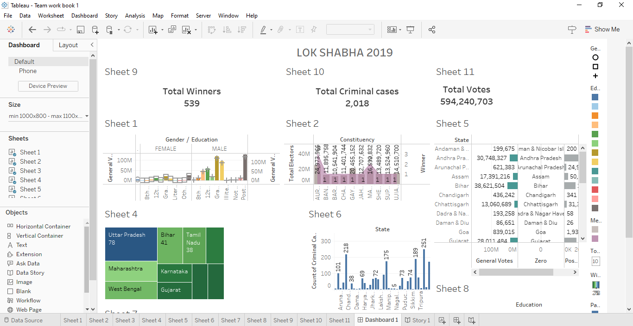

# Stories.

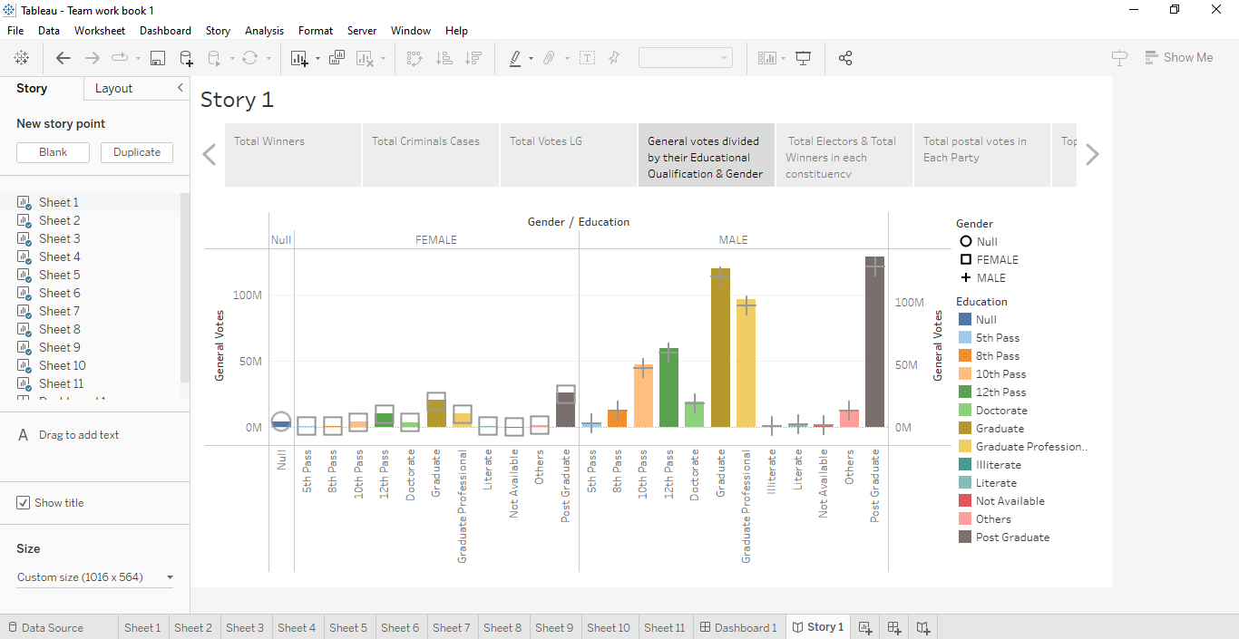

# Advantages & Disadvantages.

# List of advantages.

* **The Lok Sabha is the lower house of parliment of India.**
* **The members of the lok sabha are elected by the universal adult suffrage.**
* **The tenure of the lok sabha is 5 years.**
* **It helps in proper functioning of democracy through the system of checks & balances.**
* **No confidence motion can only be introduced & passed in the Lok sabha.**

# List of disadvantages.

* **The Lok sabha, the lower house of India’s Parliament, plays a crucial role in the country’s democratic process.**
* **Members of the Lok sabha often vote along party lines due to the strong influence of political parties & the whip system.**
* **The Lok sabha sometimes faces disruptions, walkouts, & adjournments due to the adversarial nature of Indian politics.**
* **Some groups may be underrepresented, leading to policy decisions that do not adequalety adderss their concerns.**

# Aplications.

# The Areas where this solution can be applied.

* **The maximum membership of the house allotted by the**

**Constitution of India.**

* **The community were also nominated by the president of India on the advice of government of India.**
* **The Lok sabha, unless sooner dissolved, continues to operate for five years form the date appointed for its first meeting.**
* **An exercise to redraw Lok sabha constitunencies’ boundaries is carried out by the boundry Delimitation Commision of India.**
* **This exercise earlier also included redistribution of seats among states based on demographic.**

# Conclusion.

Conclusion summarizing the entire work & findings.

* **Then the candidate was said polling was by & large peacefull baring some incidents of violence.**
* **Their added that this year’s general elections were more peaceful as compared to the edition.**
* **The proclamation of emergency in operation, this period may be extended by parliament of law.**

# Future scope.

# Enhancements that can be made in the future.

**The Lok Sabha has certain powers that make it more powerful than the Rajya Sabha.**

**Motions of no confidence against the government can be introduced and passed in**

**The Lok Sabha. If passed by a majority vote, the Prime Minister and the council of**

**Ministers resign collectively.**